1. Write a program which takes 5 inputs from user for different subject’s

marks, total it and generate mark sheet using grades ?

Code:

subject1=int(input("ENTER Mark Of The First Subject: "))  
subject2=int(input("ENTER Mark Of The Second Subject: "))  
subject3=int(input("ENTER Mark Of The Third Subject: "))  
subject4=int(input("ENTER Mark Of The Forth Subject: "))  
subject5=int(input("ENTER Mark Of The Fifth Subject: "))   
obtainmark = subject1 + subject2 + subject3 + subject4 + subject5;  
print("YOUR OBTAIN MARK",obtainmark)  
average = obtainmark/5  
if(average>=85 and average<=100):  
 print("Your Grade is A+");  
elif(average>=75 and average<85):  
 print("Your Grade is A");  
elif(average>=65 and average<75):  
 print("Your Grade is B+");  
elif(average>=55 and average<65):  
 print("Your Grade is B");  
elif(average>=50 and average<=55):  
 print("Your Grade is C+");  
elif(average>=0 and average<=40):  
 print("Your Grade is F");  
else:  
 print("Strange Grade..!!");

Output:

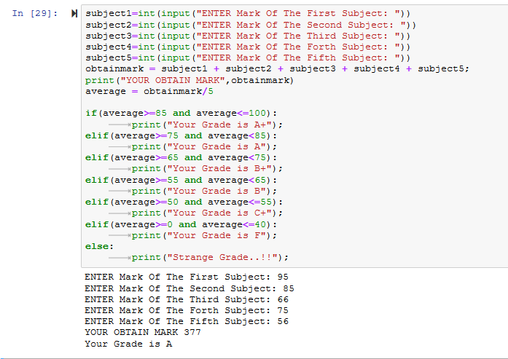

2. Write a program which take input from user and identify that the given

number is even or odd?

Code:

num = input("Enter any number: ");  
number = float(num);  
if num:  
 check = number%2;  
 if check == 0:  
 print(int(number), "is an even number.");  
 elif check == 1:  
 print(int(number), "is an odd number.");

else:  
 print(number, "is strange.");

Output:

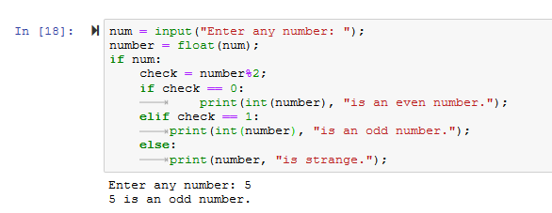

3. Write a program which print the length of the list?

Code:

a = [2,4,5,4,523,4,5]

print(len(a))

Output:

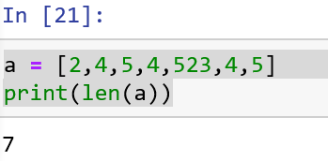

4. Write a Python program to sum all the numeric items in a list?

Code:

a = [1, 1, 2, 3, 5, 8, 13, 21, 34, 55, 89]

b = sum(a)

print(b)

Output:

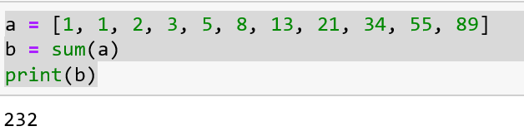

5. Write a Python program to get the largest number from a numeric list.

Code:

list = [10, 20, 24, 45, 99]

print("largest number in the list ",max(list))

Output:

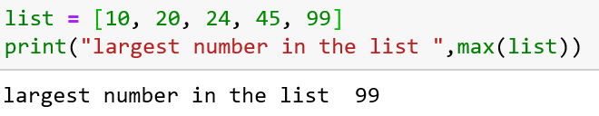

6. Take a list, say for example this one:

a = [1, 1, 2, 3, 5, 8, 13, 21, 34, 55, 89]

and write a program that prints out all the elements of the list that are

less than 5.

Code:

a = [1, 1, 2, 3, 5, 8, 13, 21, 34, 55, 89]

for item in a:

if item < 5:

print(item)

Output:

